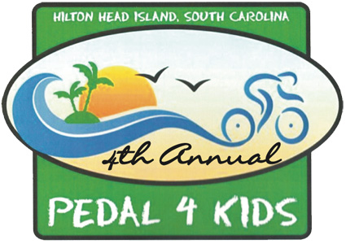BOYS & GIRLS CLUB OF HILTON HEAD
PEDAL 4 KIDS-RIDER INFORMATION

REGISTRATION
Begins at 7:30am Saturday September 25, 2010.

RULES
All riders must have waiver release form signed. All riders must wear a helmet at all times. All riders must obey all SC state traffic laws. Remember, this is a charity bike ride for fun, not a bicycling race.

START TIMES
Each wave of riders will be led by a ride leader.
- 40 mile route riders - depart at 8:30am
- 20/25 mile route riders - depart at 9:00am
- 10 mile route riders - depart at 9:30am
- Family Fun Ride will depart at 10:00am

CYCLING ROAD HAZARDS
There will be ride safety instructions provided by a League of American Bicyclists certified safety instructor before each ride, ride leaders for each staged wave of riders, route marshals at key intersections and a Beaufort County Sheriff’s vehicle stationed at key intersections. Most of the routes are on Hilton Head Island pathways; they have been cleaned and are free of debris, so the major road hazard will be inattentive other riders. Ride defensively and predictably.

RIDE NUMBERS
Each rider will have a unique ride number. Please pin the number to the back of your jersey. The numbers identify participants in the event for rest stops, sag wagon drivers and police awareness.

ROUTE MAPS AND MARKINGS
All routes will be marked with directional cones. All riders will receive route maps and cue sheets to assist them on their selected route. Riders will “release” from the start area in waves. Each wave will have an identified ride leader. 40 mile riders will have ride leaders, but should use their route maps and cue sheets.

REST STOPS AND BATHROOMS
There will be multiple rest stops conveniently placed around the route. Each rest stop will have bathroom facilities, sun screen, basic first aid supplies, drinks and snacks. The start/finish area will also have coffee at the start and pizza, hotdogs, subs and soft drinks at the finish.

SAG WAGON – is a support vehicle for cyclists
There will be two SAG wagons patrolling the routes in the event of mechanical bike failures, flat tires or if other help is needed. If you need help, pull off the pathway or road and signal with a pat on your helmet when a SAG wagon comes by. HAM operators will be on the SAG wagons and at the rest stops to signal for help. There will be a central communications center in contact with the SAG wagons and HAM operators.
Call 703-955-0277. In the event of a medical emergency, dial 911

REFRESHMENTS
There will be plenty of drinks, power bars, cookies and bananas available at the rest stops. Soft drinks, pizza, subs and other refreshments will be available at the finish line.

